**PROJECT**

**Deploy a Static Website on AWS**



**TASK**

**Creating a static website and deploy it using AWS services.**



**PREREQUISITE:**

1. AWS Account ( either route or IAM user)
2. Knowledge about S3 Bucket
3. Concept of static website
4. Files index.html and error. html

**STATIC WEBSITE HOSTING ARCHITECTURE DIAGRAM :**

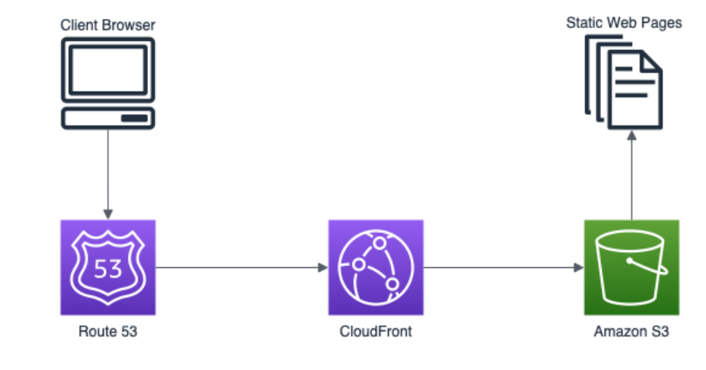

**Step 1: Sign In to your AWS Management Console**



**Step 2: Navigate to S3**

* Search for **S3** in the search box of your AWS account.
* Click on the first result.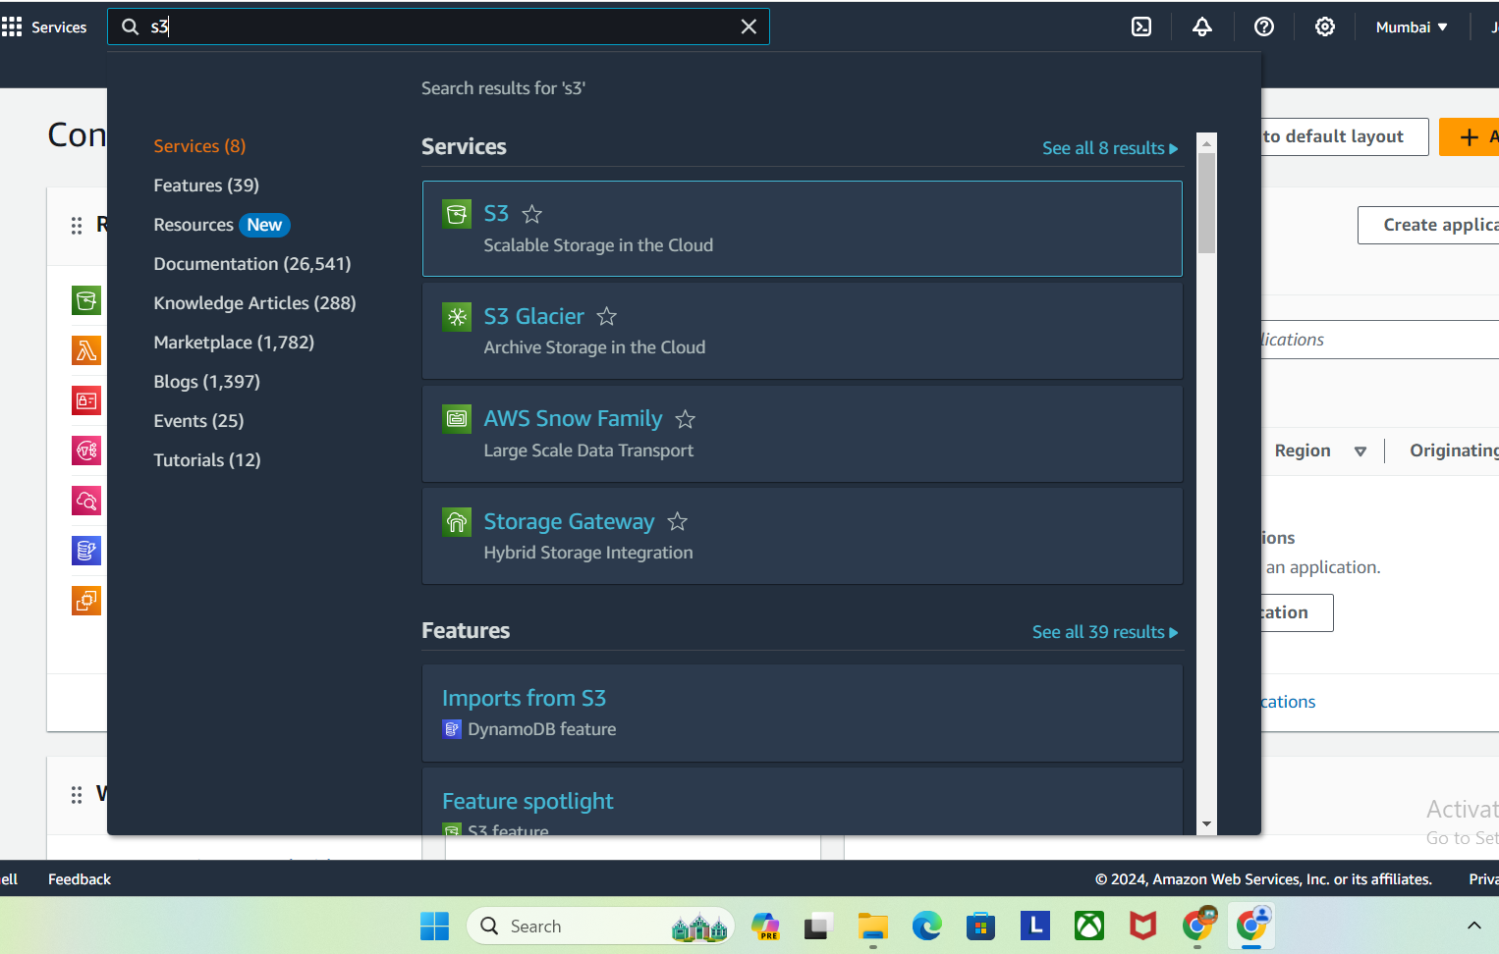

**Step 3: Create a bucket**

Firstly , we need to create an S3 bucket and allowing it public access for hosting a static website .

* In S3 dashboard , click on **Create Bucket .**

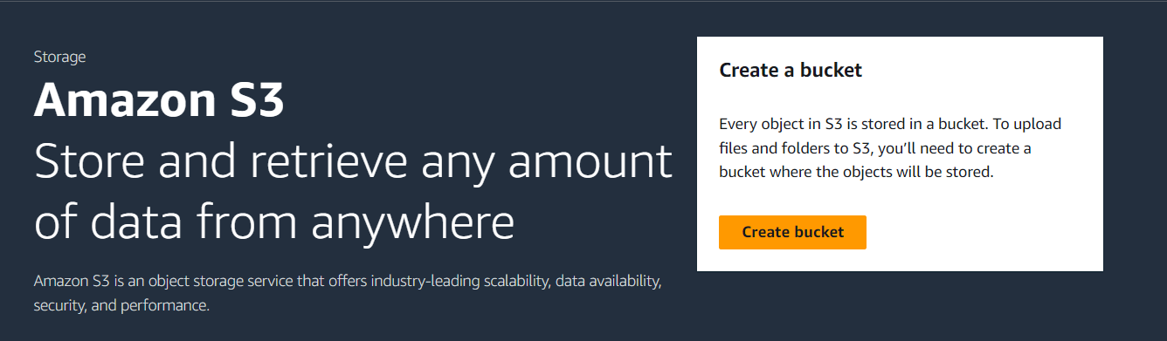

* In general configuration, under **Bucket name** :

Enter name for the bucket ( e.g.**webserver895** )

(S3 Bucket name should be globally unique )

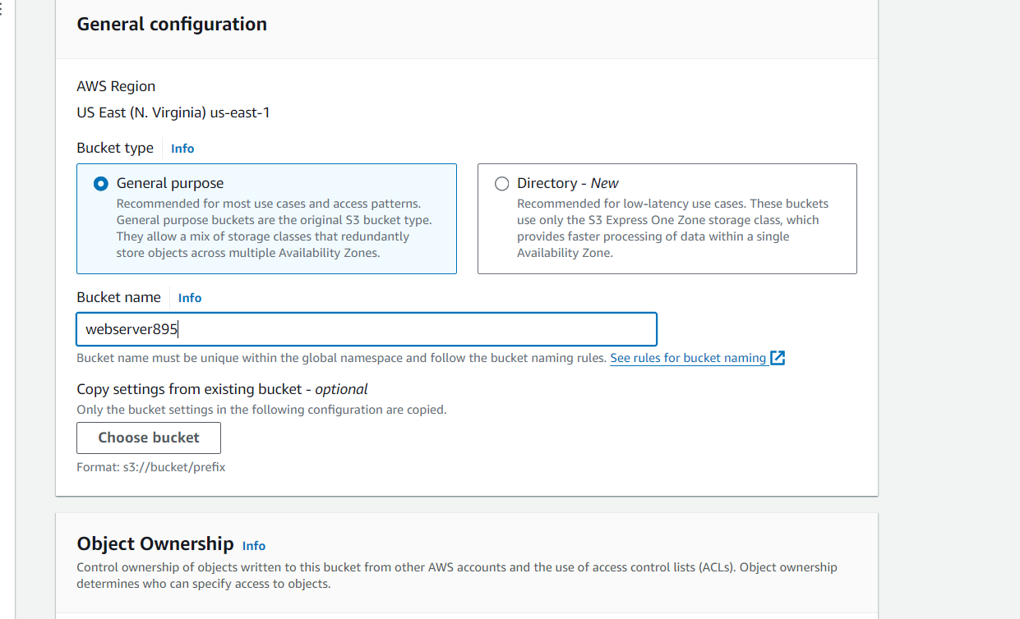

* In AWS region :

Select **US East (N.Virginia) us-east-1**

* Object ownership:

Select **ACLs disabled (recommended)** option

* In the option of **Block Public Access settings for this bucket**, **Uncheck** the option of **Block all public access**.
* **Check** the I acknowledge that the current settings might result in this bucket and the objects within becoming public checkbox.
* Keep everything default and click on **Create 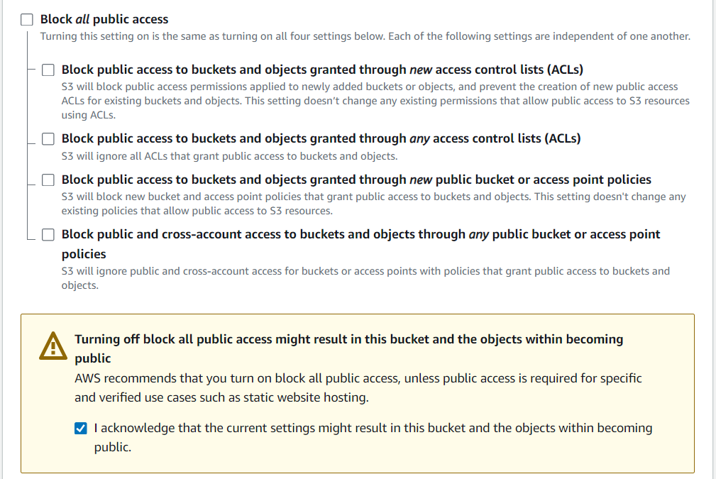Bucket** button.
* Now your S3 Bucket is created.

**Step 4 : Do Bucket Configuration**

In our previous step, we have successfully created a bucket. Now we have to do some configurations to make this Bucket host a  **“static website”**

and  **“publically accessible”.**

* Go to your Bucket List and click on your previously created Bucket.
* Go to Bucket’s “**Properties**”.

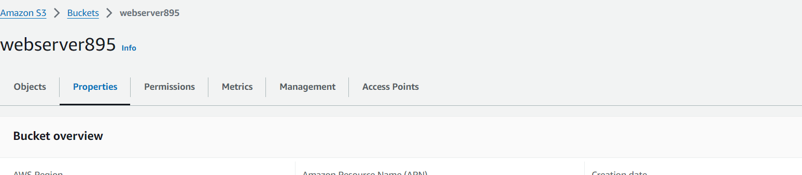

* Now scroll down and at the bottom, you will see the option **“Static Hosting”** - Enable this option.

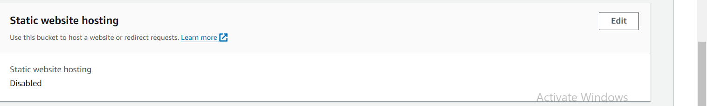

* Write **index.html** in this index document field.

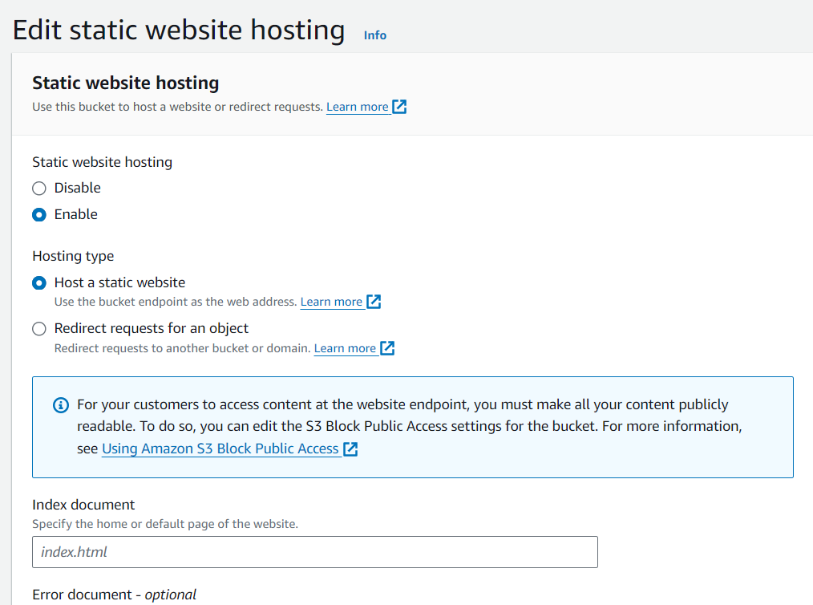

* Write **error.html** in this error document field.
* Now click on **Save** changes.

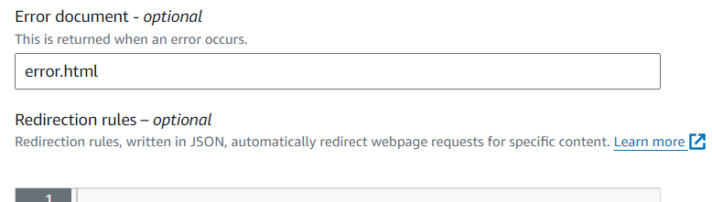

**Step 5 : Editing Bucket Policy**

* In the S3 Buckets list, go to your created Bucket’s

**Permissions.**

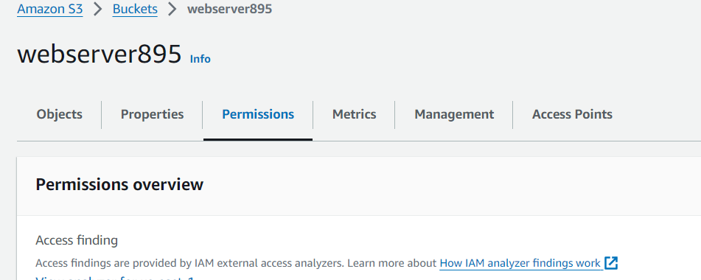

* Scroll down and add **Policies** to this Bucket to make it publically accessible.

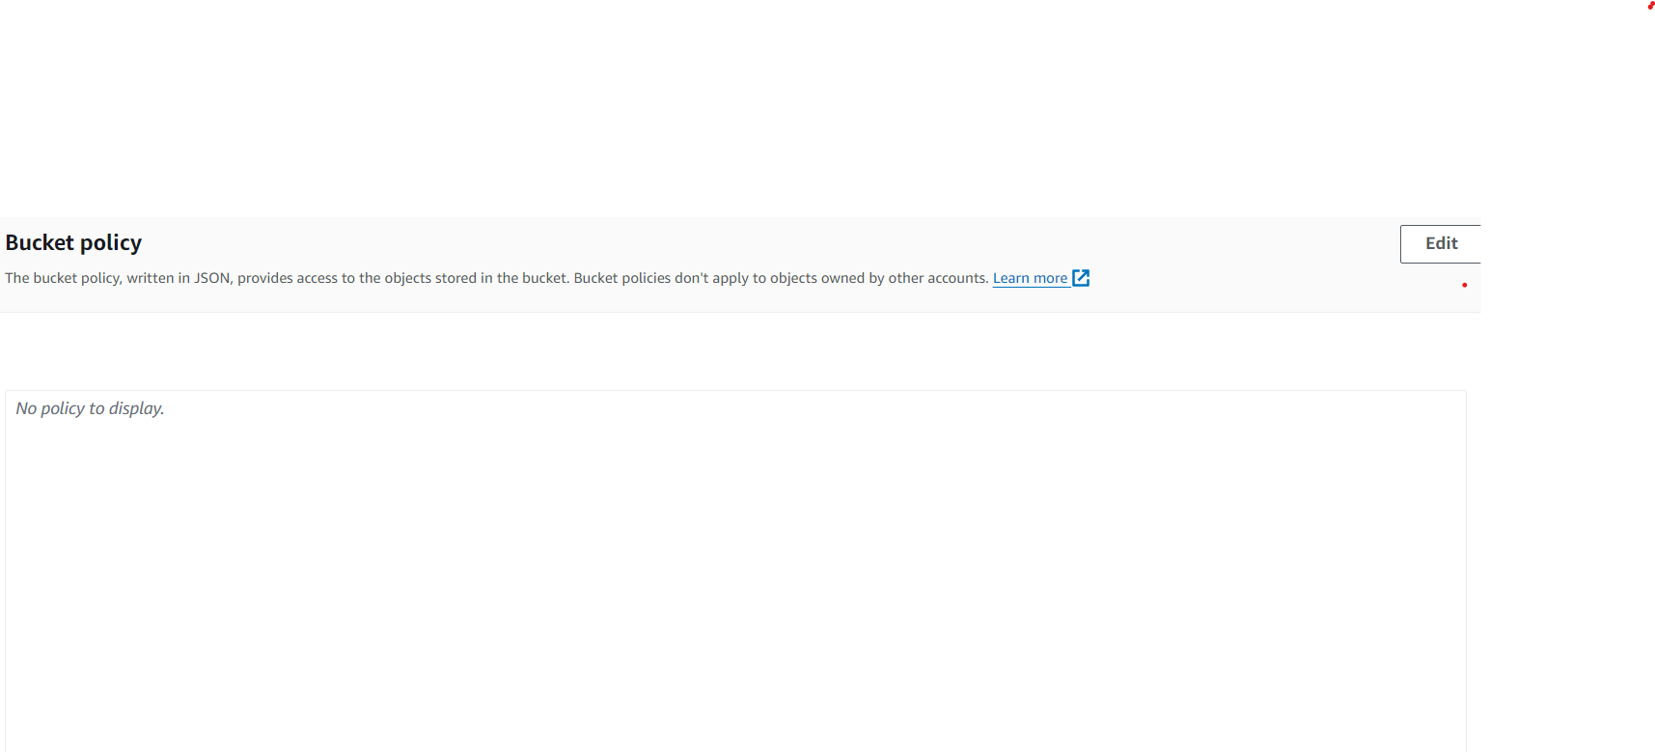

* Click on **Edit.**
* Then, **Add Statement.**
* Now add **Policy** to make it publically accessible.

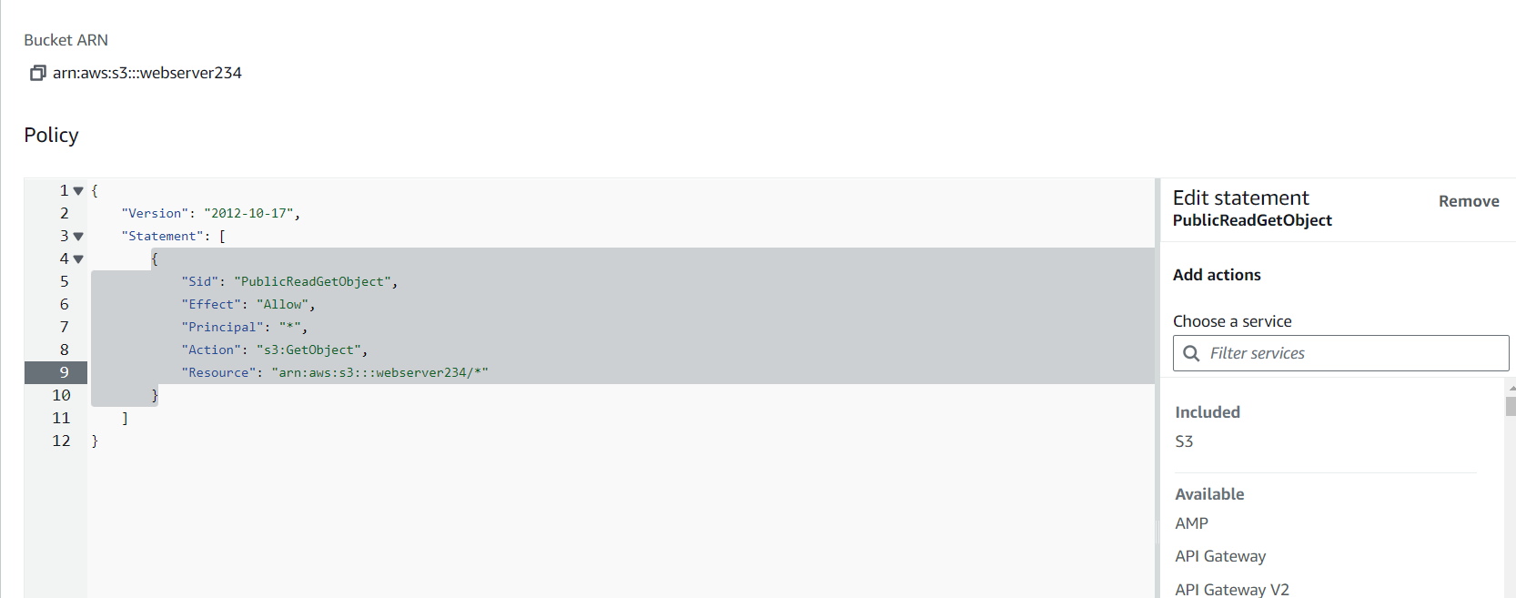

* Now **Save** changes.

**Step 6 : Adding objects to the Bucket**

* Go to your S3 Bucket.
* Then ,**Upload** option.
* Add **index.html** and **error.html** files to your bucket.

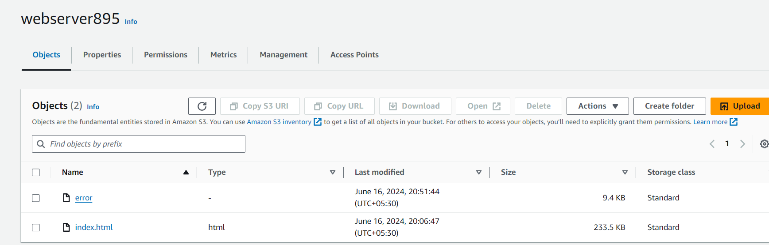

* After the upload is complete, simply click on the **index.html** file.

**Step 7 : Test the static website**

* Now copy the static website URL .

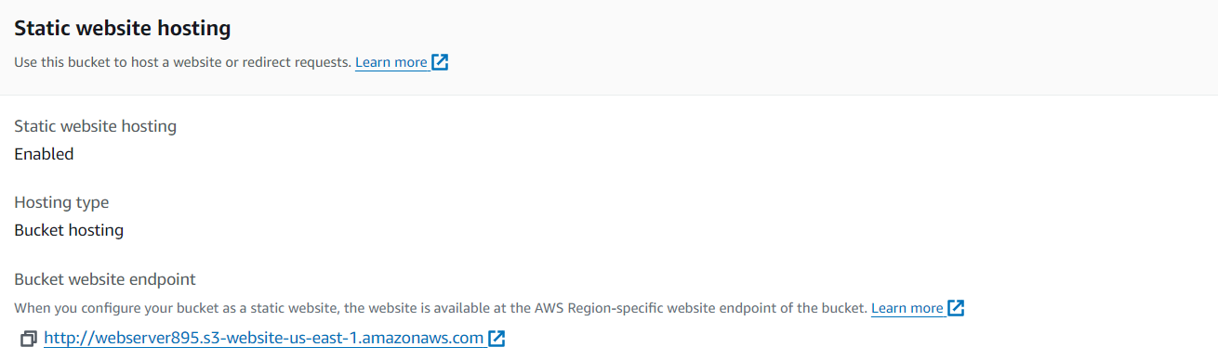

* Run the copied URL , you will be able to see the index.html file's text.

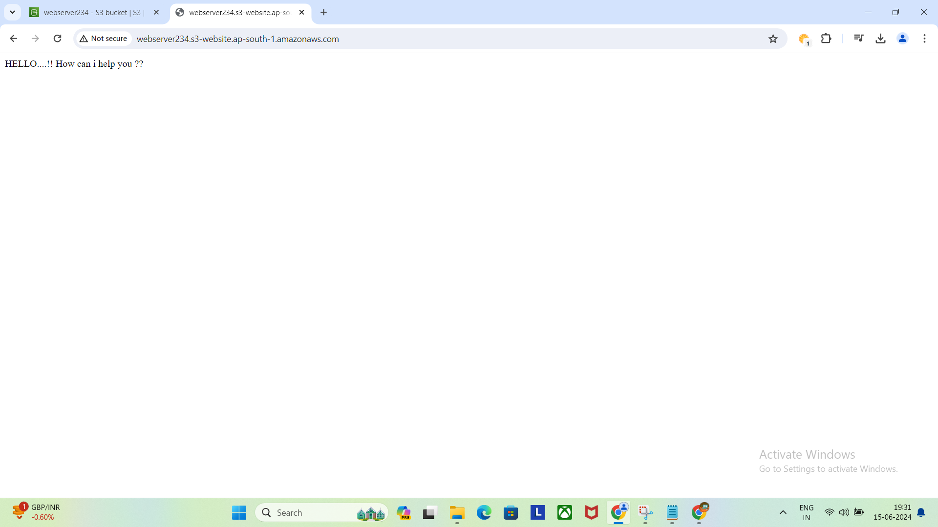

**Step 8: Test the website's error page**

* Copy the static website URL (which we saved earlier) , but this time, add some random characters to the end of the url to break it. When satisfied, hit [Enter].
* You will be redirected to the error.html page automatically.

